Elsie McCabe Thompson
President
e: elsie@missionsociety.org p: 212.674.3500 x202 c: 212.674.3500
missionsociety.org
est. 1812

Email-Signature Instructions for Outlook
- Select the table and copy it – this is incase you need to revert to the original table.
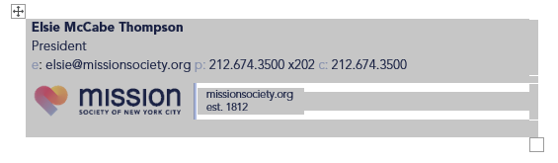
- Replace content with personal information. Ensure email is linked to to the correct email (right click the email, then select edit hyperlink). It should look like this:

- Save the file with both the original and your personalized signature. Copy the personalized table like in step 1. Open outlook and select new email.\

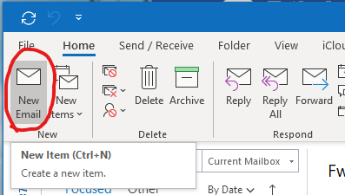

- Then select “Signatures…” from the signature dropdown
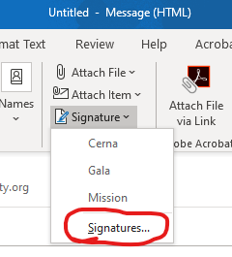
- Create a new email signature named Mission or Mission2020 and paste in the personalized email signature you copied in step 3. Replicate the default signature settings as shown below (circled).
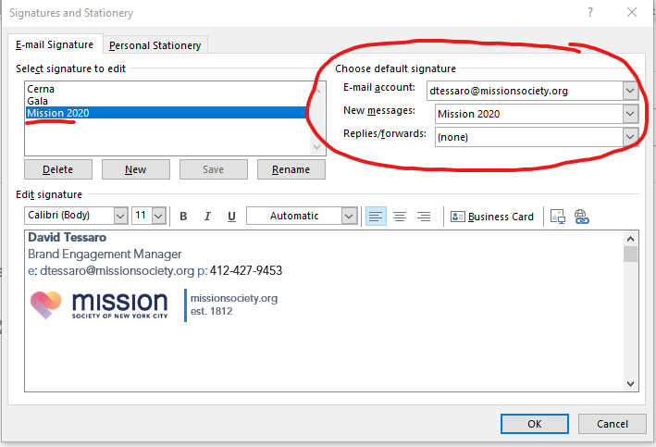

- Save and press OK. Close the window and open a new e-mail from outlook. It should look like the following:

